Introduction 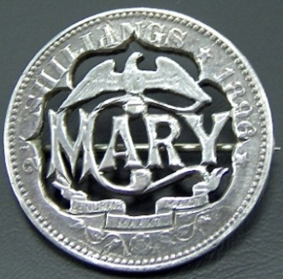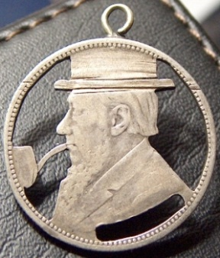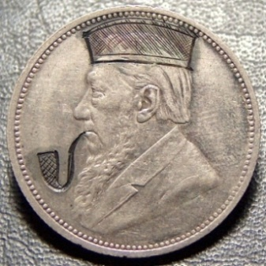
Through the centuries, lovers have chosen a variety of different mediums to express their love or affection for someone special in their lives. Some of the more popular “tokens of love” were carved wooden spoons, thimbles, pin cushions, and rings. Thimbles and pin cushions were acceptable gifts. Young men wanting to show their affection might then try to acquire the most ornate decorative thimble they could find to present to their beloved. Some had pretty floral patterns, others were embellished with enamel or jewels, and many were made of precious metals like silver or even gold. During the Victorian period the ever popular valentine card was introduced. This period also marked the peak of popularity for using engraved coins as love tokens. In the late 18th century and through the 19th century, engraved coins were widely given as an expression of love. Often, men could not afford to buy their sweetheart a ring, so instead, they would save up to purchase the largest coin denomination they could afford, personalize it, and give to their love upon asking for their hand in marriage. One side of the coin would be sanded down smooth and engraved with the girl's initials or sometimes their name. The coins sometimes had embellishments such as a border or other design added as well. The coins were carried by the woman throughout the marriage. Many times a hole was added and it was worn around the neck, or a pin back was added and it was worn near the heart. Since the engravings were generally done by common men (not trained artists), it is amazing to see the detail and quality of some coins. Engraved coins were also often given by sailors to girls as promises that they will come back to them after their journey, and so that the girl might have something to remember him by.
What Are Love Tokens 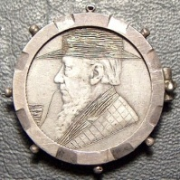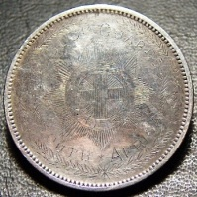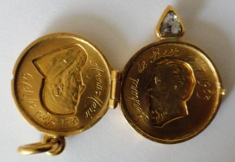
The Love Token is a coin that has been smoothed flat on one or both sides and then hand engraved. Engravings are most commonly initials of the giver or the person receiving the Love Token. Names and dates were also popular and perhaps most special and scarcer were sayings and pictures. Some love tokens were embellished even further with stones, enamel, added raised metal, or cutout designs within the coin. These coins were made as keepsakes and mementos from the giver to the recipient. The giver, important date, place, or event was intended to be remembered through the love token; a commissioned testimony and executed one of a kind special engraving. Coins personalized for a sweetheart were given as an expression of love, and often as a proposal of marriage. These coins, engraved with their loved one's initials, or sometimes their name, were a precious and cherished gift. Some love tokens withstood the test of time and now, years later, they serve as a testament to a love that was - a romance of old.
"...as a token of my love." --- That is such a powerfully romantic phrase!
There are two basic requirements for a love token:
- First: The engraving must be on a legitimate coin (i.e. coin of the realm).
- Second: The engraving must be done by hand.
Of course if a coin is engraved on both sides, it becomes more challenging to identify if indeed it is a coin or a blank disc. Most South African coins have a reeded edge, so love token collectors accept the presence of a reeded edge to be a legitimate coin. The ZAR 1d & 3d and the Union 1/4d, 1/2d, 1d & 3d pose a problem with no identifying marks on the rim as they are smooth. Also, a coin that has been cut down into another shape (diamond, clover, heart etc…) loses its edge diagnostics. In these cases, it is up to the collector whether they want to accept it or not into their collection.
Also under challenge or interpretation is the coin of the realm notion. Medals and tokens that have been engraved and presented to the masses are clearly not love tokens. But what of a war medal that is hand engraved, one of a kind, and on a personal note? Let’s say a son dies in war and the family is given a medal. Then the father has it enameled in black with the son’s name and presents it to his wife, the boy’s mother. Is this any less of a love token if all the sentiments are there? Again, it is up to the collector whether they wish to accept it in their own collection. Opinions will vary.
Although it is traditionally believed that these coins were given by a man to a lady, they extended far beyond those traditional boundaries. They were also given by every imaginable family member as well as friends. A craze had sweet the country and school girls were begging and pleading for love tokens. Probably because the love token bracelet was the most popular form of love token jewelry and it took about eight to make a bracelet during the war.
Engravings were executed on practically all denominations of coins, but the Paul Kruger 1s, 2s & half crown was the most popular denomination. There is some speculation as to the reasons. These silver coins were softer, thus easier to engrave than nickel and were a more precious gift than a nickel or the lowly copper penny. South Africa also produced a 3d and 6d made from silver and some engraved on these coins, but it was a rather small size and perhaps challenging for the engraver to fit a pleasing design so small. These denominations are scarcer to obtain. Remember, money was worth a lot more in those days.
Gold coins were used occasionally. Truly rare and exceedingly scarce is the gold coin love token. A Kruger half pond and pond are sometimes seen with love messages, but they are very far and few in-between. This would have only been commissioned by a very wealthy man.
Interestingly enough, a few number of the copper coins was engraved as well. These are also very scarce. Whatever the host coin, the feelings and emotions were the same. Some could just afford to show their love more than others.
Boer War P.O.W coins are very highly collectable. Many depicting Kruger with a Hat and Pipe, some with Regimental emblems engraved some Cut Outs and some with personal greetings or messages. This period also shows us many enameled coins. Most of these POW coins were done by men captured and taken to POW camps in St Helena, Ceylon etc. With the many number of months spent in these camps captured as prisoners, and with the constant thought of their loved ones back home, many resorted to messages on coins and sent these back home to their loved ones. There are some spectacular art on some coins and all of these were hand done. Many look the same, but when closely examined you will see they are all unique as they were all hand made.
People were quite sentimental in the Victorian age and love tokens are an enduring testament to those feelings.
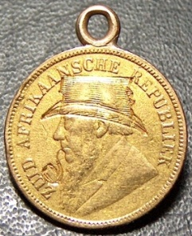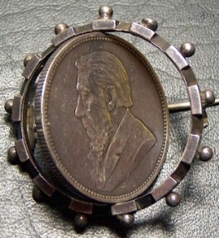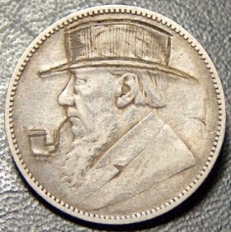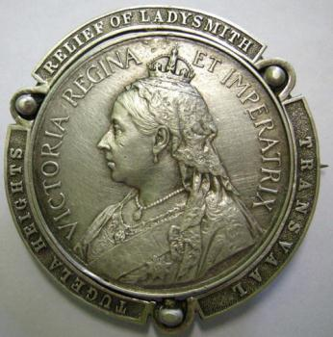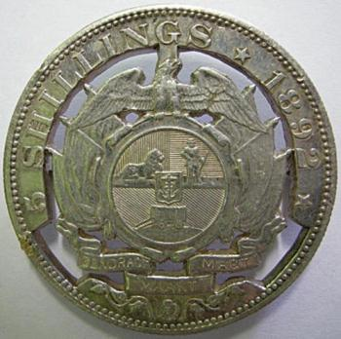
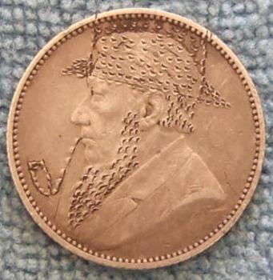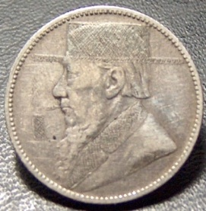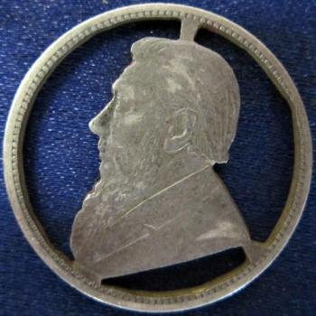

Anthony Govender

